JAVAMS11 Working with Cloud Spanner

**Overview**

In this series of labs, you take a demo microservices Java application built with the Spring framework and modify it to use an external database server. You adopt some of the best practices for tracing, configuration management, and integration with other services using integration patterns.

In a previous lab, you modified the application to use Cloud SQL for database services. Cloud SQL provides a managed database service for applications that require robust relational database services. But when higher performance and transactions are critical to your application, you can use Cloud Spanner to provide high-performance, relational database services. Cloud Spanner is an enterprise-grade, globally distributed, strongly consistent database service built for the cloud specifically to combine the benefits of relational database structure with non-relational horizontal scale. This combination delivers high-performance transactions and strong consistency across rows, regions, and continents with enterprise-grade security.

In this lab, you update your application to use the Spring Cloud GCP starter for Cloud Spanner, test the changes locally in Cloud Shell, and then redeploy the backend service to App Engine.

**Objectives**

In this lab, you learn how to perform the following tasks:

* Create a Cloud Spanner instance and database
* Use the data definition language (DDL) to create a Cloud Spanner table
* Use Spring to add support for Cloud Spanner to an application
* Modify a Java application to use Cloud Spanner instead of Cloud SQL

**Task 0. Lab Preparation**

**Access Qwiklabs**

**How to start your lab and sign in to the Console**

1. Click the **Start Lab** button. If you need to pay for the lab, a pop-up opens for you to select your payment method. On the left is a panel populated with the temporary credentials that you must use for this lab.

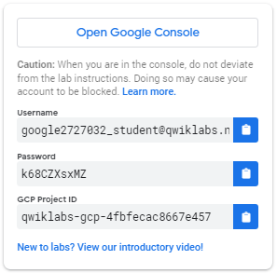

1. Copy the username, and then click **Open Google Console**. The lab spins up resources, and then opens another tab that shows the **Choose an account** page.

***Tip:*** Open the tabs in separate windows, side-by-side.

1. On the Choose an account page, click **Use Another Account**.

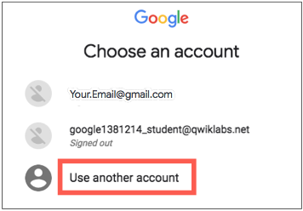

1. The Sign in page opens. Paste the username that you copied from the Connection Details panel. Then copy and paste the password.

***Important:*** You must use the credentials from the Connection Details panel. Do not use your Qwiklabs credentials. If you have your own GCP account, do not use it for this lab (avoids incurring charges).

1. Click through the subsequent pages:
   * Accept the terms and conditions.
   * Do not add recovery options or two-factor authentication (because this is a temporary account).
   * Do not sign up for free trials.

After a few moments, the GCP console opens in this tab.

**Note:** You can view the menu with a list of GCP Products and Services by clicking the **Navigation menu** at the top-left, next to “Google Cloud Platform”. 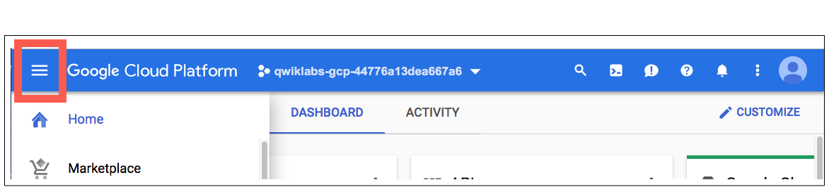

After you complete the initial sign-in steps, the project dashboard appears.

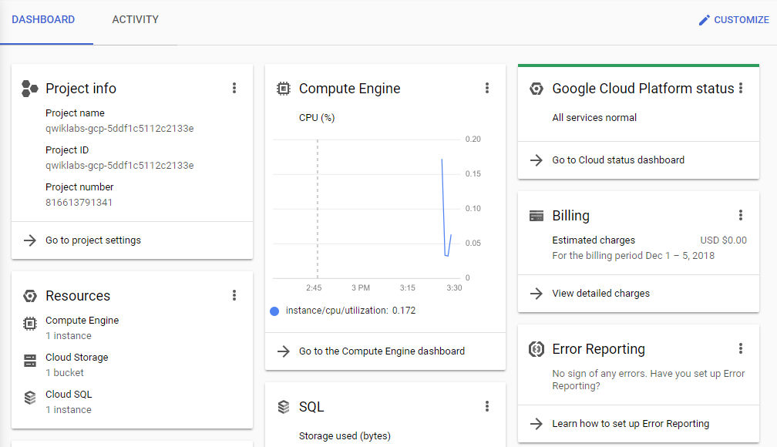

**Fetch the application source files**

To begin the lab, click the **Activate Cloud Shell** button at the top of the Google Cloud Console. To activate the code editor, click the Open Editor button on the toolbar of the Cloud Shell window. You can switch between cloud shell and code editor by using Open Editor and Open Terminal icon as required.

**Note:** A Cloud Storage bucket that is named using the project ID for this lab is automatically created for you by the lab setup. The source code for your applications is copied into this bucket once the Cloud SQL server is ready and both application microservices components have been deployed to App Engine. You might have to wait up to 10 minutes for the deployment tasks to complete.

1. In the Cloud Shell command line, enter the following command to create an environment variable that contains the project ID for this lab:

export PROJECT_ID=$(gcloud config list --format 'value(core.project)')

1. Verify that the demo application files were created.

gsutil ls gs://$PROJECT_ID

1. Copy the application folders to Cloud Shell.

gsutil -m cp -r gs://$PROJECT_ID/* ~/

1. Make the Maven wrapper scripts executable.

chmod +x ~/guestbook-frontend/mvnw

chmod +x ~/guestbook-service/mvnw

1. Check that the frontend application is running. You can find the URL of the frontend application that should now be running on App Engine via the following command:

gcloud app browse

1. Click the link to open a browser tab to the frontend URL. You will come back to this later.

**Task 1. Enable Cloud Spanner API**

In this task, you enable Cloud Spanner API so that you can create a Cloud Spanner database for your application.

1. Switch back to the Cloud Shell and enable the Cloud Spanner API.

gcloud services enable spanner.googleapis.com

**Task 2. Create a new Cloud Spanner instance**

In this task, you create a Cloud Spanner instance, a database and a database table.

**Create a Cloud Spanner instance**

You create a Cloud Spanner instance and then create a database on that instance for the demo application.

1. Create a Cloud Spanner instance.

gcloud spanner instances create guestbook --config=regional-us-central1 \

--nodes=1 --description="Guestbook messages"

1. Create a messages database in the Cloud Spanner instance.

gcloud spanner databases create messages --instance=guestbook

1. Confirm that the database exists by listing the databases of the Cloud Spanner instance.

gcloud spanner databases list --instance=guestbook

The output indicates that the database is ready:

NAME STATE

messages READY

**Create a table in the Cloud Spanner database**

You create a table in the messages database by creating a file that contains a DDL statement and then running the command.

1. In the guestbook-service folder, create the db folder.

cd ~/guestbook-service

mkdir db

1. In the Cloud Shell code editor, create a file named spanner.ddl in the ~/guestbook-service/db/ directory.
2. Add the following commands to the spanner.ddl file:

CREATE TABLE guestbook_message (

id STRING(36) NOT NULL,

name STRING(255) NOT NULL,

image_uri STRING(255),

message STRING(255)

) PRIMARY KEY (id);

1. In the Cloud Shell use gcloud to run the DDL command to create the table.

gcloud spanner databases ddl update messages \

--instance=guestbook --ddl="$(<~/guestbook-service/db/spanner.ddl)"

1. In the Google Cloud console, use the navigation menu to navigate to **Spanner** in the **Storage** section.
2. Click the name of the **Guestbook messages** instance to open it.
3. Click the name of the **messages** database to open it.

You should see the **guestbook_message** table if the spanner.ddl file was processed successfully.

1. Click the **guestbook_message** table to open it.

The database opens showing the schema details tab. The schema should match the schema you created in the spanner.ddl file.

1. Click the **Data** tab. There is no data in the table yet.

**Task 3. Add Spring Cloud GCP Cloud Spanner Starter**

In this task, you update the Guestbook Service's pom.xml file to remove the Cloud SQL starter, and add the Cloud Spanner Starter dependency.

1. Switch back to the tab running the Cloud Shell code editor.
2. In the editor, open ~/guestbook-service/pom.xml.
3. Delete the Spring Data JPA by removing these lines:

<dependency>

<groupId>org.springframework.boot</groupId>

<artifactId>spring-boot-starter-data-jpa</artifactId>

</dependency>

1. Delete the Cloud SQL Starter by removing these lines:

<dependency>

<groupId>org.springframework.cloud</groupId>

<artifactId>spring-cloud-gcp-starter-sql-mysql</artifactId>

</dependency>

1. Delete HSQL by removing these lines:

<dependency>

<groupId>org.hsqldb</groupId>

<artifactId>hsqldb</artifactId>

<scope>runtime</scope>

</dependency>

1. Now, add the following code at the end of the <dependencies> section, immediately before the closing </dependencies> tag:

<dependency>

<groupId>org.springframework.cloud</groupId>

<artifactId>spring-cloud-gcp-starter-data-spanner</artifactId>

</dependency>

**Task 4. Update configuration**

In this task, you add the Cloud Spanner instance and database configuration properties to application.properties and application-cloud.properties for the guestbook backend service application. You will also delete the Cloud SQL configuration properties.

There is no Cloud Spanner emulator, meaning both Dev and Prod will always need a real Cloud Spanner instance running. For the purpose of this lab, we'll use the same Spanner instance.

1. In the editor, open guestbook-service/src/main/resources/application.properties. Delete the two Cloud SQL Configuration lines and add the following Spanner configuration:

# Add Spanner configuration

spring.cloud.gcp.spanner.instance-id=guestbook

spring.cloud.gcp.spanner.database=messages

1. Next, open guestbook-service/src/main/resources/application-cloud.properties and remove the following Spring properties for Cloud SQL:

spring.cloud.gcp.sql.enabled=true

spring.cloud.gcp.sql.database-name=messages

spring.cloud.gcp.sql.instance-connection-name=...

**Task 5. Update the backend service to use Cloud Spanner**

You can use the @Table annotation to map a Java class to a Cloud Spanner table. And you can use the @Column annotation to map properties to table columns. You use the @Table annotation to map to the guestbook_message table that was created when you ran the DDL statement with gcloud.

The id property is specified as the primary key. In the class constructor, the id property is auto-populated with a random UUID. The UUIDv4 format is recommended over a monotonically increasing ID. This format helps Cloud Spanner avoid creating hotspots when it automatically shards the data.

The other class properties included match the table's schema in the DDL statement, except for imageUri, which uses the @Column annotation to map the table column name image_uri to the property name imageUri.

In this task, you modify GuestbookMessage.java to use the Cloud Spanner annotations.

1. In the Cloud Shell code editor, open guestbook-service/src/main/java/com/example/guestbook/GuestbookMessage.java.
2. Replace the entire contents of this file with the following code:

package com.example.guestbook;

import lombok.*;

import org.springframework.cloud.gcp.data.spanner.core.mapping.*;

import org.springframework.data.annotation.Id;

import com.fasterxml.jackson.annotation.JsonIgnoreProperties;

@Data

@Table(name = "guestbook_message")

@JsonIgnoreProperties(value={"id"}, allowSetters = false)

public class GuestbookMessage {

@PrimaryKey

@Id

private String id;

private String name;

private String message;

@Column(name = "image_uri")

private String imageUri;

public GuestbookMessage() {

this.id = java.util.UUID.randomUUID().toString();

}

}

**Task 6. Add a method to find messages by name**

Spring Data Spanner implements many commonly used Spring Data patterns, such as creating simple methods that can be automatically translated to corresponding SQL queries.

One example is a simple method signature: List<GuestbookMessage> findByName(String name);. The Spring framework enables querying the Cloud Spanner table with the SQL query SELECT * FROM guestbook_message WHERE name = ?.

In this task, you update the GuestbookMessageRepository.java file to use String as the ID type.

1. In the Cloud Shell code editor, open guestbook-service/src/main/java/com/example/guestbook/GuestbookMessageRepository.java.
2. Insert the following import statement below the existing import directives:

import java.util.List;

1. Change the datatype for the PagingAndSortingRepository GuestbookMessage parameter from Long to String.

public interface GuestbookMessageRepository extends

PagingAndSortingRepository<GuestbookMessage, String> {

}

1. Insert the following code into the definition for the GuestbookMessageRepository public interface, immediately before the closing brace:

List<GuestbookMessage> findByName(String name);

The GuestbookMessageRepository.java file should now look like the screenshot: 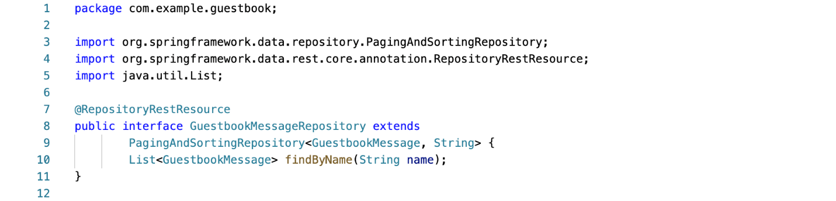

**Task 7. Test the backend service application locally in Cloud Shell**

In this task, you run the updated guestbook backend service application in Cloud Shell in order to test that the application has been correctly configured to use Cloud Spanner for database services.

1. In the Cloud Shell change to the guestbook-service directory.

cd ~/guestbook-service

1. Launch the guestbook backend service application locally:

./mvnw spring-boot:run

1. In a new Cloud Shell tab, use curl to post a message.

curl -XPOST -H "content-type: application/json" \

-d '{"name": "Ray", "message": "Hello Cloud Spanner"}' \

http://localhost:8081/guestbookMessages

1. List all the messages.

curl http://localhost:8081/guestbookMessages

1. List specific messages using the custom findByName() search you added above.

curl http://localhost:8081/guestbookMessages/search/findByName?name=Ray

1. Use the gcloud spanner command with a SQL query to validate that messages exist.

gcloud spanner databases execute-sql messages --instance=guestbook \

--sql="SELECT * FROM guestbook_message WHERE name = 'Ray'"

1. Switch back to the the Google Cloud Platform console and navigate to your Spanner guestbook_message database to see the new entry.

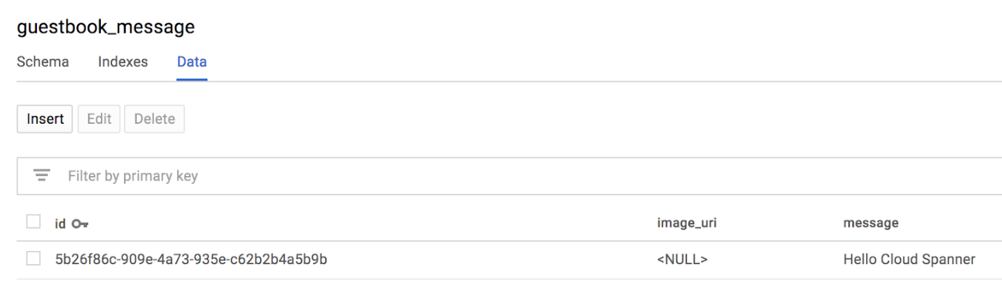

1. Click **Query** on top of the page and then click **Run query**, with the default SELECT query.

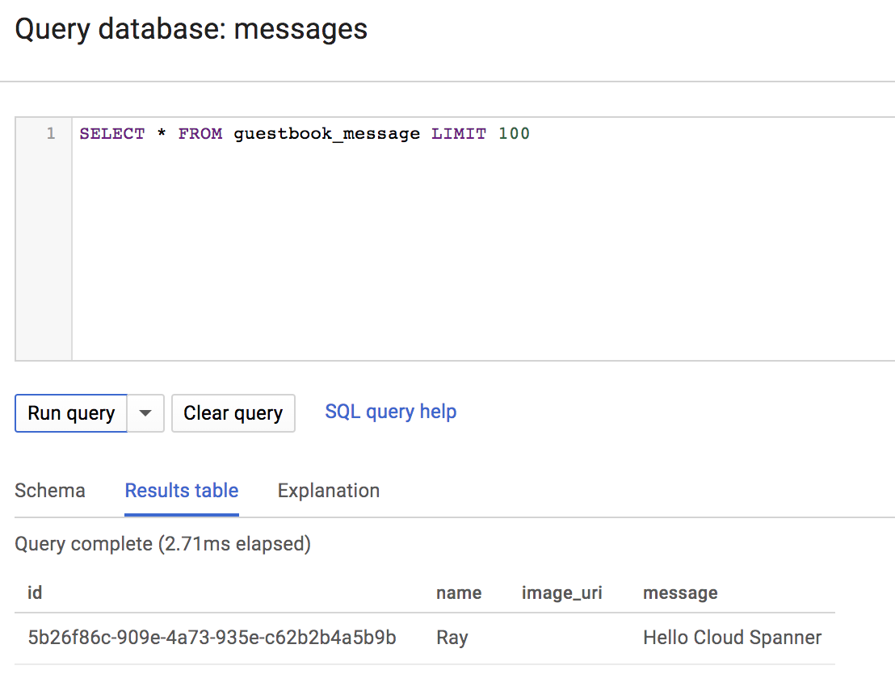

**Task 8. Redeploy the backend service application to App Engine**

In this task, you redeploy the updated guestbook backend service application to App Engine.

1. Switch back to the Cloud Shell tab where the guestbook backend service application is running.
2. Press CTRL+C to stop the application.
3. Make sure you are in the guestbook-service directory.

cd ~/guestbook-service

1. Use Apache Maven to rebuild the backend service application redeploy it to App Engine.

mvn package appengine:deploy -DskipTests

When the deployment completes, the output from Maven provides the URL of the updated backend service application.

...

[INFO] GCLOUD: Deployed service [guestbook-service] to [https://guestbook-service-dot-PROJECT_ID.appspot.com]

[INFO] GCLOUD:

[INFO] GCLOUD: You can stream logs from the command line by running:

[INFO] GCLOUD: $ gcloud app logs tail -s guestbook-service

[INFO] GCLOUD:

[INFO] GCLOUD: To view your application in the web browser run:

[INFO] GCLOUD: $ gcloud app browse -s guestbook-service

...

1. Use the following command to list the URLfor the updated backend service application.

gcloud app browse -s guestbook-service

A clickable URL link to your new backend service appears.

Did not detect your browser. Go to this link to view your app:

https://guestbook-service-dot-....appspot.com

1. Click the URL link to open the backend guestbook service.

The response lists all the messages in the Cloud Spanner database.

1. Switch back to the browser tab for the frontend application.

**Note:** If you have closed that tab, use the following command to list the URL for the guestbook frontend application that is running on App Engine:gcloud app browse -s default. Then click the link to browse to the guestbook frontend application.

1. Enter a message to test that the application is working.

You should now see an updated message list that includes the initial test message you sent from the Cloud Shell and the new message you just posted confirming that the updated backend service application is using the new Cloud Spanner database.

**End your lab**

When you have completed your lab, click **End Lab**. Qwiklabs removes the resources you've used and cleans the account for you.

You'll be given an opportunity to rate the lab experience. Select the applicable number of stars, type a comment, and then click **Submit**.

The number of stars indicates your rating:

* 1 star = Very dissatisfied
* 2 stars = Dissatisfied
* 3 stars = Neutral
* 4 stars = Satisfied
* 5 stars = Very satisfied

You can close the dialog box if you don't want to provide feedback.

For feedback, suggestions, or corrections, use the **Support** tab.

Copyright 2019 Google LLC All rights reserved. Google and the Google logo are trademarks of Google LLC. All other company and product names may be trademarks of the respective companies with which they are associated.